|  |  |  |
| --- | --- | --- |
|  | **KONGU ENGINEERING COLLEGE**  (Autonomous)  Perundurai, Erode – 638 060  **DEPARTMENT OF ELECTRONICS AND COMMUNICATION ENGINEERING** | KEC | Kongu Engineering College |

**HAND GESTURE BASED RECOGNITION SYSTEM**

**PROJECT REPORT**

**for**

**22VP003-Mini Project**

**Submitted by**

**ABINAYA A S (22ECR006)**

**BRINDHA S (22ECR035)**

**DHANASRI G (22ECR041)**

|  |  |  |
| --- | --- | --- |
|  | **KONGU ENGINEERING COLLEGE**  (Autonomous)  Perundurai, Erode – 638 060  **DEPARTMENT OF ELECTRONICS ANDCOMMUNICATION ENGINEERING** | KEC | Kongu Engineering College |

**BONAFIDE CERTIFICATE**

Name & Roll No. :

Course Code : 22VP003

Course Name :**Mini Project**

Semester : **V**

Certified that this is a bonafide record of work for application project done by the above students for **22VP003-Mini Project** during the academic year **2024-2025.**

Submitted for the Viva Voce Examination held on _____________________

**Faculty In-Charge Year In-charge**

**TABLE OF CONTENTS**

|  |  |  |
| --- | --- | --- |
| **CHAPTER No.** | **TITLE** | **PAGE No.** |
|  | **Abstract** |  |
| **1.** | **Introduction and Problem Statement** |  |
| **2.** | **Methodology** |  |
| **3.** | **Design and Implementation** |  |
| **4.** | **Results and Discussion** |  |
| **5.** | **Conclusion** |  |

**ABSTRACT**

Hand recognition systems have become increasingly vital in fields such as security, gesture control, and human-computer interaction. Traditional systems often rely on camera-based computer vision methods, which can be computationally expensive and sensitive to environmental factors like lighting conditions. To overcome these challenges, this project proposes a hand recognition solution using motion sensors, the STM32CubeIDE development environment, and NanoEdge AI tools.

The proposed system leverages motion sensors to capture precise hand movements, reducing dependency on visual data and enhancing reliability across diverse environments. The use of motion sensors allows for real-time tracking of dynamic hand gestures, enabling the system to interpret complex patterns such as swipes, rotations, and unique motion sequences. This sensor-driven approach ensures higher resilience to environmental variations, such as low lighting or visual obstructions, which are common challenges in camera-based systems.STM32CubeIDE facilitates efficient integration and firmware development for STM32 microcontrollers, while NanoEdge AI tools enable rapid machine learning model training and deployment directly on embedded devices. By combining sensor-based data acquisition with optimized AI models, this solution achieves high accuracy with minimal computational overhead.

This approach not only addresses the limitations of traditional methods but also provides a compact, energy-efficient, and scalable framework for real-time hand recognition applications, paving the way for robust gesture-based control systems.

**CHAPTER I**

**INTRODUCTION AND PROBLEM STATEMENT**

**INTRODUCTION:**

Hand gesture recognition has emerged as a vital technology in human-computer interaction, offering intuitive and non-intrusive control for a wide range of applications, including smartwatches, IoT devices, and assistive technologies. This project focuses on designing and implementing a hand gesture recognition system using an STM32 Nucleo board, leveraging the capabilities of NanoEdge AI Studio and motion sensors such as accelerometers and gyroscopes.

The core objective is to create a lightweight, efficient, and real-time gesture recognition system suitable for embedded applications. The STM32 Nucleo board serves as the processing platform due to its computational efficiency and compatibility with machine learning models optimized for embedded environments. NanoEdge AI Studio facilitates the development of compact AI models tailored to recognize distinct hand gestures with high accuracy.

**PROBLEM STATEMENT:**

Traditional hand recognition systems predominantly rely on camera-based computer vision techniques, which often suffer from challenges such as high computational demands, sensitivity to lighting conditions, and susceptibility to environmental obstructions. These limitations hinder the reliability and scalability of such systems, especially in resource-constrained or variable settings. There is a need for a robust, energy-efficient, and environment-independent solution for hand recognition that can operate effectively in real time.

**CHAPTER II**

**METHODOLOGY**

The development of the hand gesture recognition system is based on a systematic approach that includes multiple key stages: **data acquisition, preprocessing, feature extraction, model training and optimization,** and **firmware development**. Each stage contributes significantly to ensuring the accuracy, efficiency, and reliability of the system when deployed on an embedded platform like the STM32 Nucleo board.

The initial phase involves data acquisition, employing motion sensors like accelerometers and gyroscopes to gather real-time motion signals. These sensors identify hand movements by assessing linear acceleration, angular velocity, and rotational dynamics.

Data is gathered in both controlled settings, such as laboratories, and in varied conditions to guarantee that the model can effectively generalize to real-world scenarios. Controlled settings facilitate accurate gesture recording without external interference, whereas varied conditions replicate practical applications, encompassing diverse lighting, noise levels, and user differences.

The unprocessed data obtained from sensors frequently includes noise, which can arise from environmental influences or the intrinsic limitations of the equipment. To mitigate this issue, preprocessing procedures are employed to enhance the data quality for subsequent analysis. Various noise reduction methods, including low-pass, median, or Kalman filters, are utilized to eliminate high-frequency noise and stabilize the signal. This process guarantees that only pertinent information is preserved.

**BLOCK DIAGRAM:**

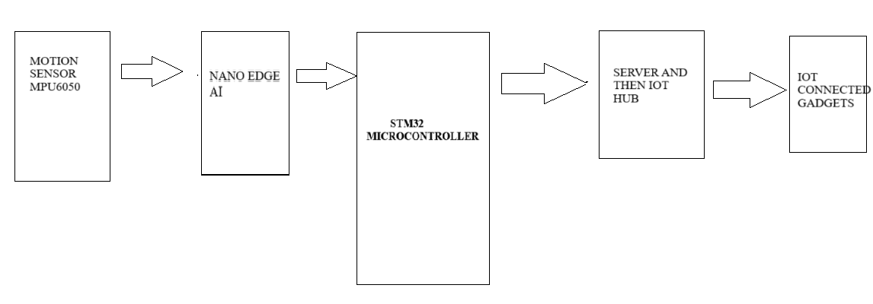

**DESIGN AND IMPLEMENTATION:**

The system is designed to recognize hand gestures by capturing and processing motion data from sensors such as accelerometers and gyroscopes. These sensors detect linear and rotational movements, which form the basis for gesture recognition.

The hardware design incorporates the STM32 Nucleo board as the central processing unit, chosen for its compatibility with NanoEdge AI Studio and its efficient handling of embedded AI tasks. The motion sensors are interfaced with the board using communication protocols like I2C or SPI, ensuring seamless data transfer.

The implementation phase begins with hardware integration. The STM32 Nucleo board is connected to the motion sensors, and the setup is tested to confirm accurate data collection. The STM32CubeIDE is used to program the microcontroller, setting up configurations for sensor interfacing, data acquisition, and communication protocols.

The raw motion data collected from the sensors is first preprocessed to remove noise using digital filtering techniques like low-pass filters. Preprocessing also involves segmenting the data into distinct gesture patterns based on timestamps and thresholds. This segmentation helps isolate meaningful data for further analysis.

NanoEdge AI Studio is used to automate this process and generate optimized features compatible with embedded AI algorithms. Once the features are extracted, the dataset is used to train machine learning models in NanoEdge AI Studio. Various algorithms, including classification models and anomaly detection, are tested to select the most accurate and computationally efficient model. The trained model is then converted into a format suitable for deployment on the STM32 board.

Firmware development involves integrating the trained AI model with the microcontroller code. Using STM32CubeIDE, the model is embedded into the system's firmware alongside routines for real-time sensor data acquisition and processing. The firmware is optimized to balance accuracy, responsiveness, and computational efficiency. Special attention is given to reducing latency and ensuring the model operates within the hardware’s memory and processing limits

Real-time testing and validation are carried out to ensure the system recognizes gestures accurately under different conditions. Tests include assessing recognition accuracy, system latency, and robustness to variations in user input or environmental factors. Additionally, power consumption is evaluated, and optimizations are implemented to extend battery life, making the system suitable for wearable devices.

The design and implementation of the hand gesture recognition system revolve around developing a reliable, efficient, and embedded solution tailored for use with the STM32 Nucleo board. The process begins with defining the system's architecture and hardware requirements, followed by the systematic integration of software components, including machine learning algorithms, firmware, and real-time processing capabilities.

**CHAPTER IV**

**RESULTS AND DISCUSSION:**

**RESULT:**

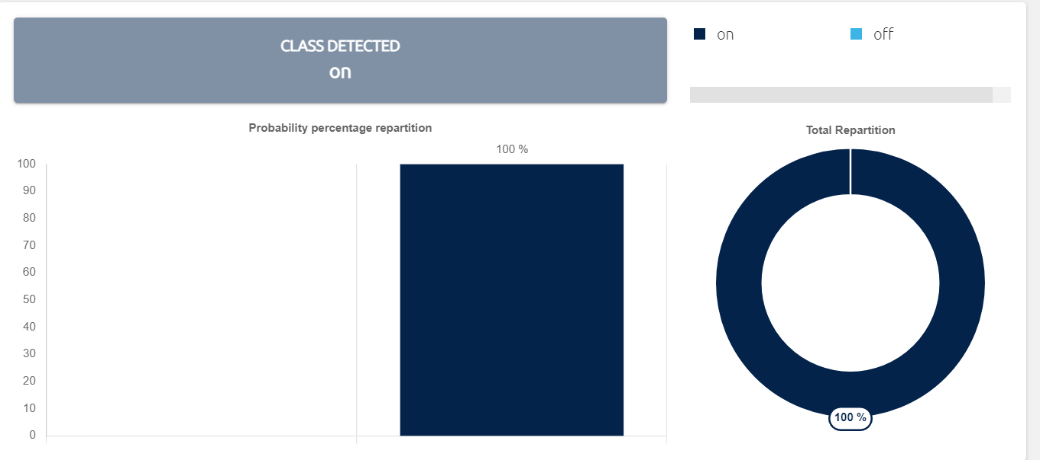

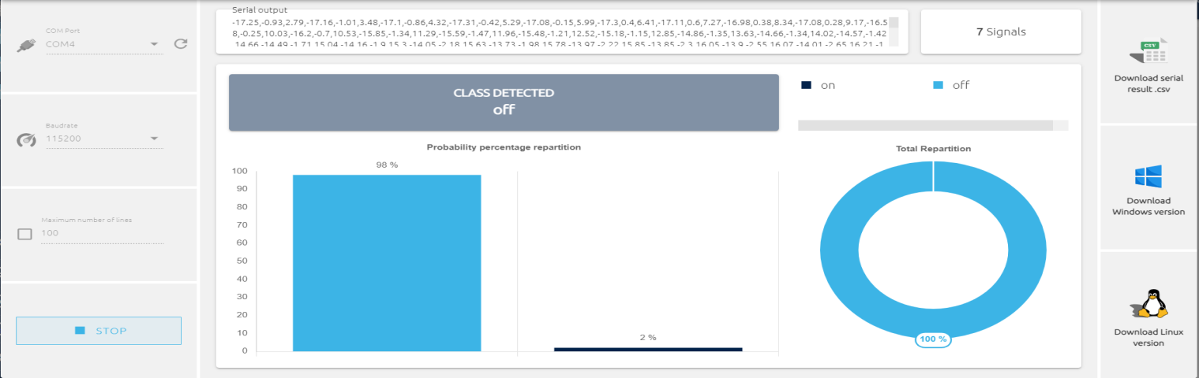

When we train the model in the Nano edge AI using motion sensor it got 96.75 accuracy and serial emulator test passed .So ,when we assume ON dataset for enabling Iot module in a home and off for disabling Iot module in a home to avoid frequent physical efforts or traditionl methods.

**CONCLUSION:**

The development of the hand gesture recognition system demonstrates the effective integration of AI techniques with embedded hardware, providing a robust and efficient solution for real-time gesture detection. By utilizing the STM32 Nucleo board, NanoEdge AI Studio, and motion sensors, the system achieves a balance between accuracy, computational efficiency, and scalability, making it suitable for wearable and IoT applications. The systematic methodology, encompassing data acquisition, preprocessing, feature extraction, model training, and firmware deployment, ensures the system is reliable and adaptable to various conditions. This project highlights the potential of embedded AI in enhancing human-computer interaction and opens avenues for further advancements in smart wearable technologies.

Bottom of Form